
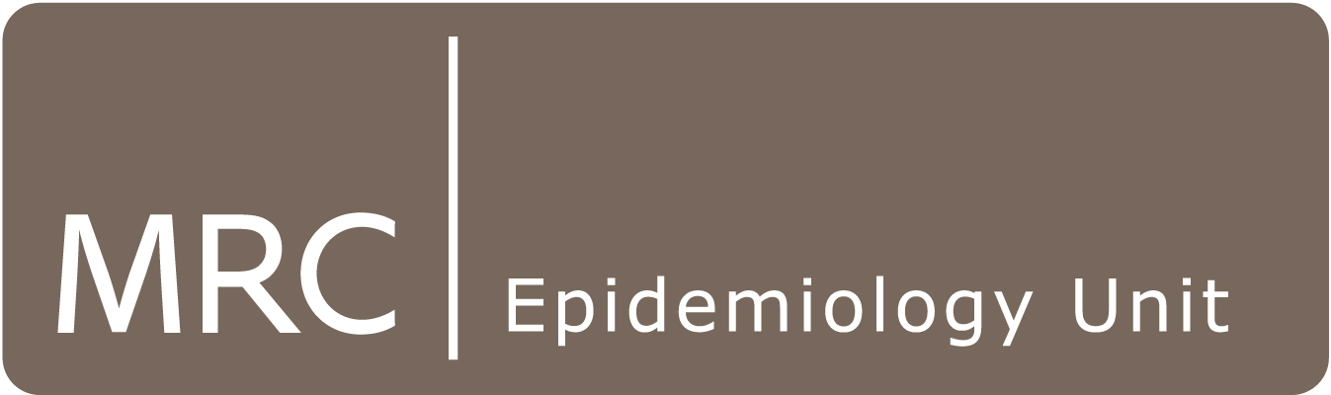
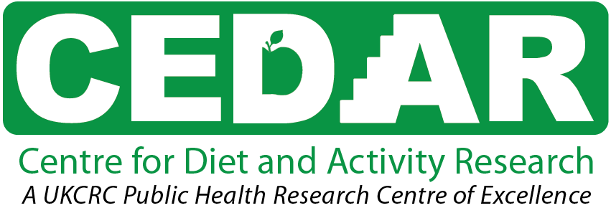

PhD Studentships in Epidemiology and Public Health Research 2016
University of Cambridge

Funded PhD studentships are available at the MRC Epidemiology Unit and the Centre for Diet and Activity Research (CEDAR), a UKCRC Centre of Excellence in Public Health Research.

The MRC Epidemiology Unit (www.mrc-epid.cam.ac.uk) is a research department in the School of Clinical Medicine at the University of Cambridge, investigating the causes and prevention of diabetes and obesity. Studentships are available in any of our programmes. These include the aetiology of diabetes and obesity, growth and development, nutritional epidemiology, physical activity epidemiology, physical activity and public health, behavioural epidemiology and diabetes prevention.

CEDAR (www.cedar.iph.cam.ac.uk) aims to understand the population-level determinants of dietary and physical activity behaviour, evaluate the effectiveness of interventions and estimate the long term costs and benefits of behaviour change. It is hosted by the MRC Epidemiology Unit in partnership with the University of East Anglia and other MRC Units in Cambridge. CEDAR is an interdisciplinary collaboration comprising diet and activity research, epidemiology, biostatistics, health geography, health economics, behavioural science, intervention development and evaluation and public health modelling (see www.cedar.iph.cam.ac.uk/research). Studentships are available in the social and environmental determinants of physical activity and dietary behaviour, population-level interdisciplinary diet and physical activity intervention research and public health modelling.

Studentships will commence in October 2016. These are 3-year positions for those who have a Masters degree, or equivalent training, in an appropriate scientific discipline. Opportunities also exist for 4-year positions for those wishing to undertake the MPhil in Epidemiology or Public Health in the first year. We provide diverse training opportunities for all aspects of research and for transferable academic and generic skills. The academic requirement for entry is a first or upper second class degree or equivalent. Graduate students register with the University of Cambridge and belong to one of its Colleges.

UK National and UK Resident Applicants – Full funding is available, for university fees and a stipend.

Other European Economic Area (EEA) Applicants – Partial funding is available, covering university fees only. Therefore, in addition to your application to us, we suggest that you also apply to other schemes for maintenance or bursary funding, e.g.:
http://www.admin.cam.ac.uk/students/studentregistry/fees/funding/chess/index.html

Non-EEA Applicants – Unfortunately you are not eligible for MRC/CEDAR funding. We would welcome your application to us, but you should additionally apply to other schemes for full funding to cover fees and stipend (note many of these have earlier deadlines). For examples, see:
http://www.mrc-epid.cam.ac.uk/work-and-study/studentships/student-finance/

To apply, please send a full CV, covering letter describing your funding eligibility status and outlining the research topic that you wish to pursue and the contact details for two academic referees to: Graduate Studies, MRC Epidemiology Unit, Institute of Metabolic Science, Cambridge Biomedical Campus Box 285, Hills Road, Cambridge, CB2 0QQ, United Kingdom or email your application or enquiries to graduatestudies@mrc-epid.cam.ac.uk. Applications missing any of the above components will not be considered. Applicants are encouraged to contact potential supervisors to discuss their research topic.

Applicants are advised to visit www.mrc-epid.cam.ac.uk/work-and-study/studentships for further information before submitting their application.

Closing date: Wednesday 6th January 2016
Interviews: Friday 29th January 2016

